2015-2016 WWMS 8th Grade Mathematics Study Guide: Unit 6 Say it With Symbols
Name: ___________________________________________ Date: ____________________________ Hour: __________
- The 8th graders are selling T-shirts and caps to raise money for their end-of-the-year party. The profit from the fundraiser depends on the number of caps and the number of t-shirts sold. To plan for the fundraiser, class officers need to know how many T-shirts and caps to order and sell. The 8th graders can make a $5 profit per t-shirt and a $10 profit per cap. The goal is to raise $600. Write an equation you could use to find the profit P if the students sell s shirts and c caps (8.EE.C.8c).

- Find a value for s and c that would earn a profit (P) of $600.00 (8.EE.C.8b).

Write the following equations in slope-intercept form (8.EE.C.8b):
***Remember to put a shape around your answer so it is easily identifiable.
- 2x – y = 17

- x – y = 10

- -x – 7y = 9

- -2x – y = 9

Write the following equation in standard form (8.EE.C.8b):
- y = -x + 2

- 3y = -4x + 6

- Graph the two equations below to find the solution to the system (8.EE.C.8b).
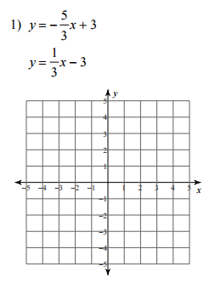
***Remember to put a shape around your answer so it is easily identifiable.

y = 3x y = 4x

***Remember to put a shape around your answer so it is easily identifiable.
- Find the solution to the system (8.EE.C.8b):

y = $-\frac{2}{3}$x$- \frac{4}{3}$ y = $-\frac{5}{3}$x– $\frac{7}{3}$

- Find the solution to the system below (8.EE.C.8b):

y = 5x – 2 y = $\frac{1}{2}$x – 2

